**Python with Django Internship Report**

**Personal Details**

Name : Parth Rupeshkumar Shah

College Name : Silver Oak College of Engineering and

Technology

Degree : BE

Semester : 7

Github URL : https://github.com/ParthShah25/Akashsir.git

**Company Details**

Company Name : Akash Technolabs

External Guide : Akash Padhiyar

Training Duration : 26-05-2021 to 21-06-2021

**Index**

|  |  |  |
| --- | --- | --- |
| **Index** | **Task Detail** | **Page Name** |
| 1 | Basic Registration page using HTML, CSS. | 3 |
| 2 | Python Variables and Datatypes. | 4 |
| 3 | Python Conditional statement, Loops, Break, Continue, Range and Pass. | 8 |
| 4 | Python OOP’s Concepts. | 16 |
| 5 | Making simple pages using Django (Home, About, Contact). | 21 |
| 6 | Career Guidance website using Django. | 25 |

1. Task – 1: Basic Registration page using HTML, CSS.

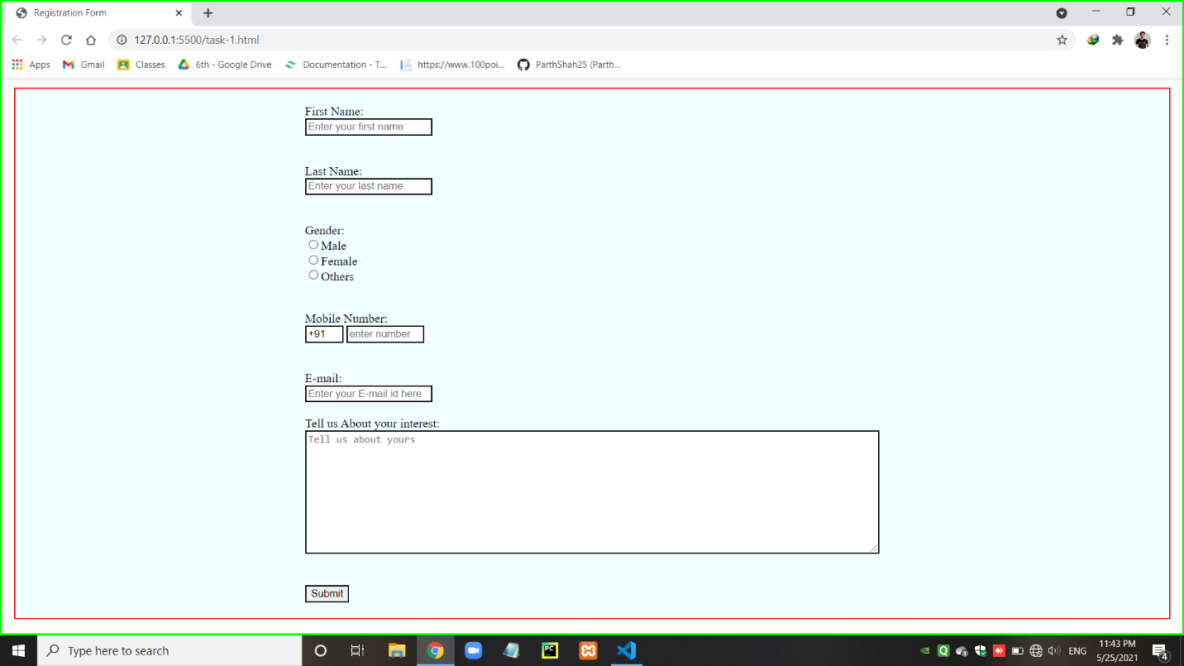

1. Task -2: Python Variables and Datatypes.

* Variable and how to know that variable’s type.

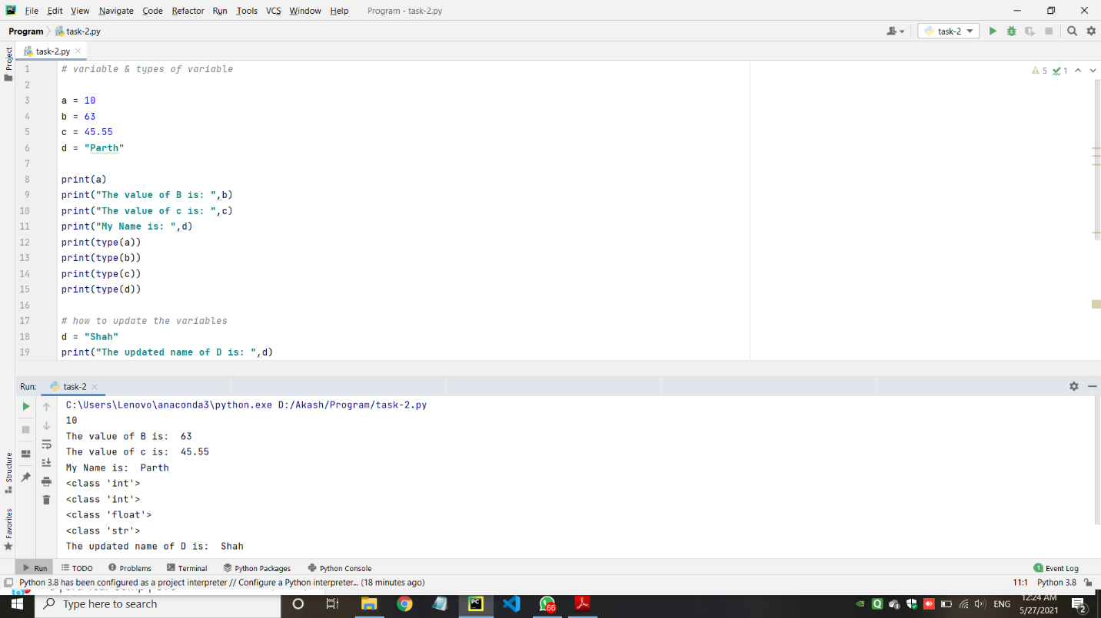

* Data Types in python
* Number Datatypes

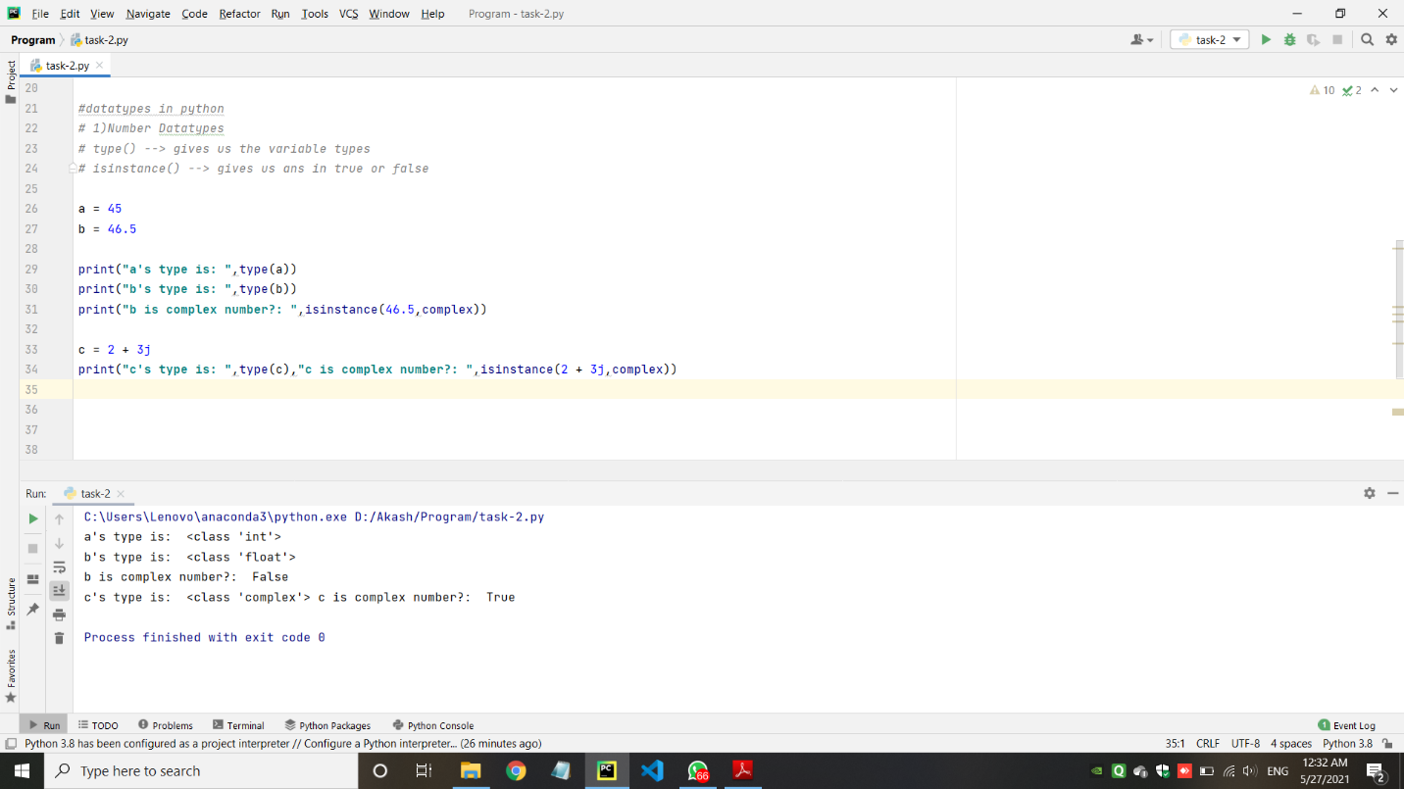

* String Datatypes

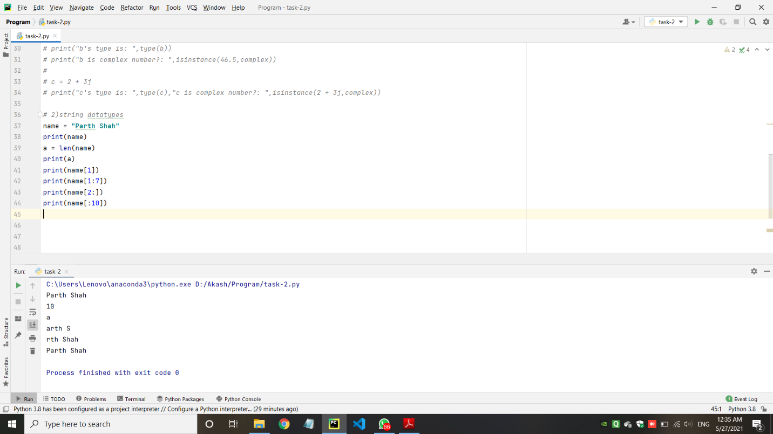

* List Datatypes

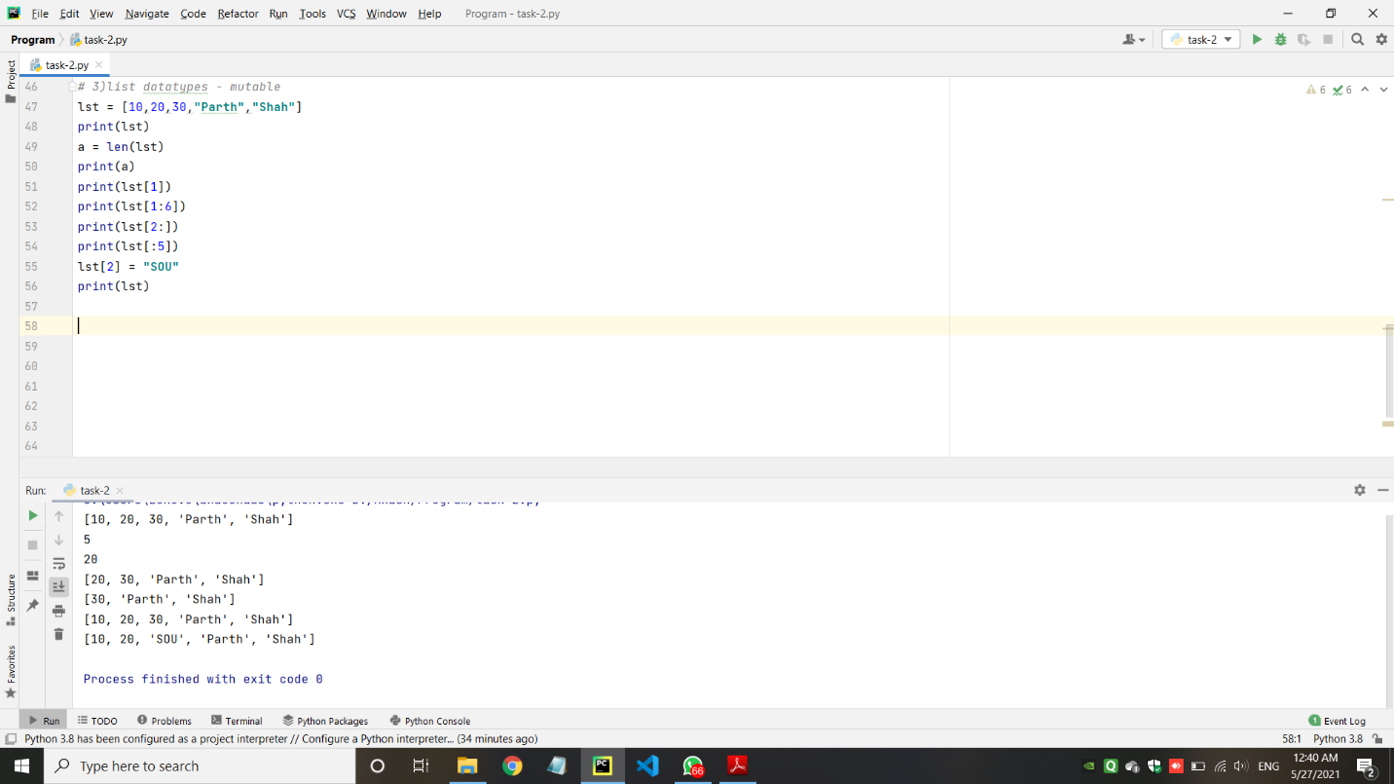

* Tuple Datatypes

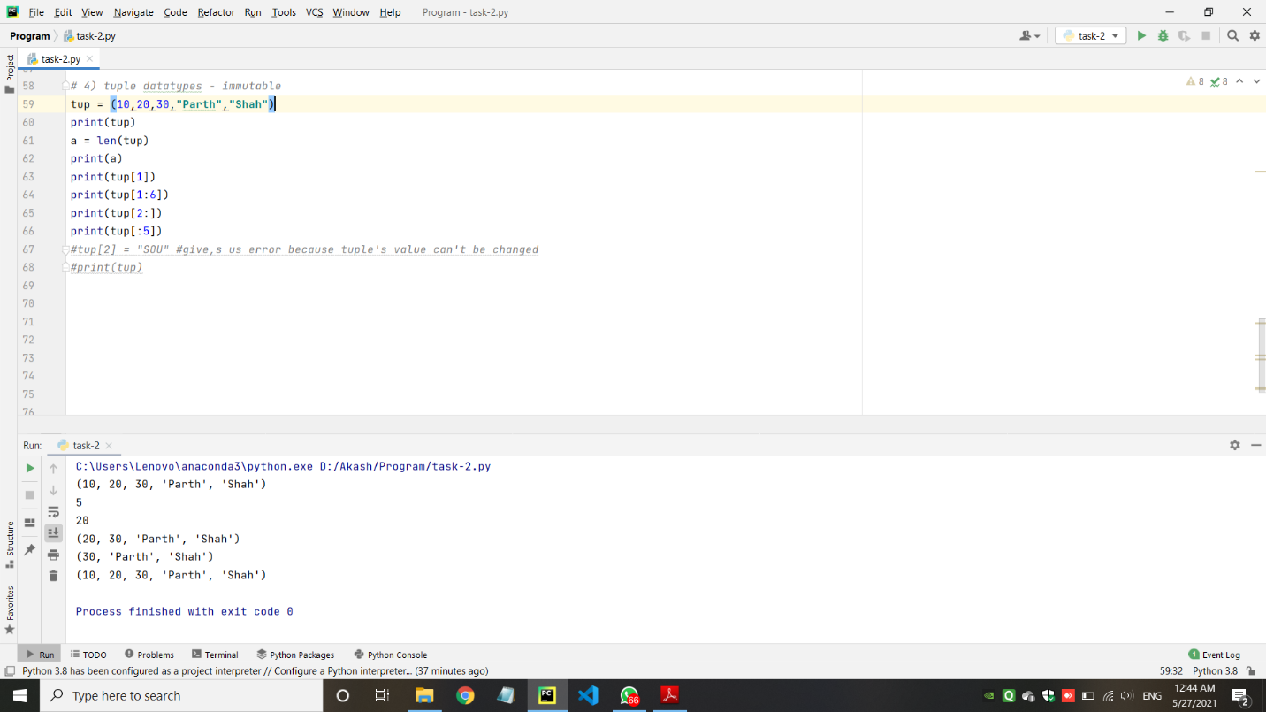

* Dictionary Datatypes

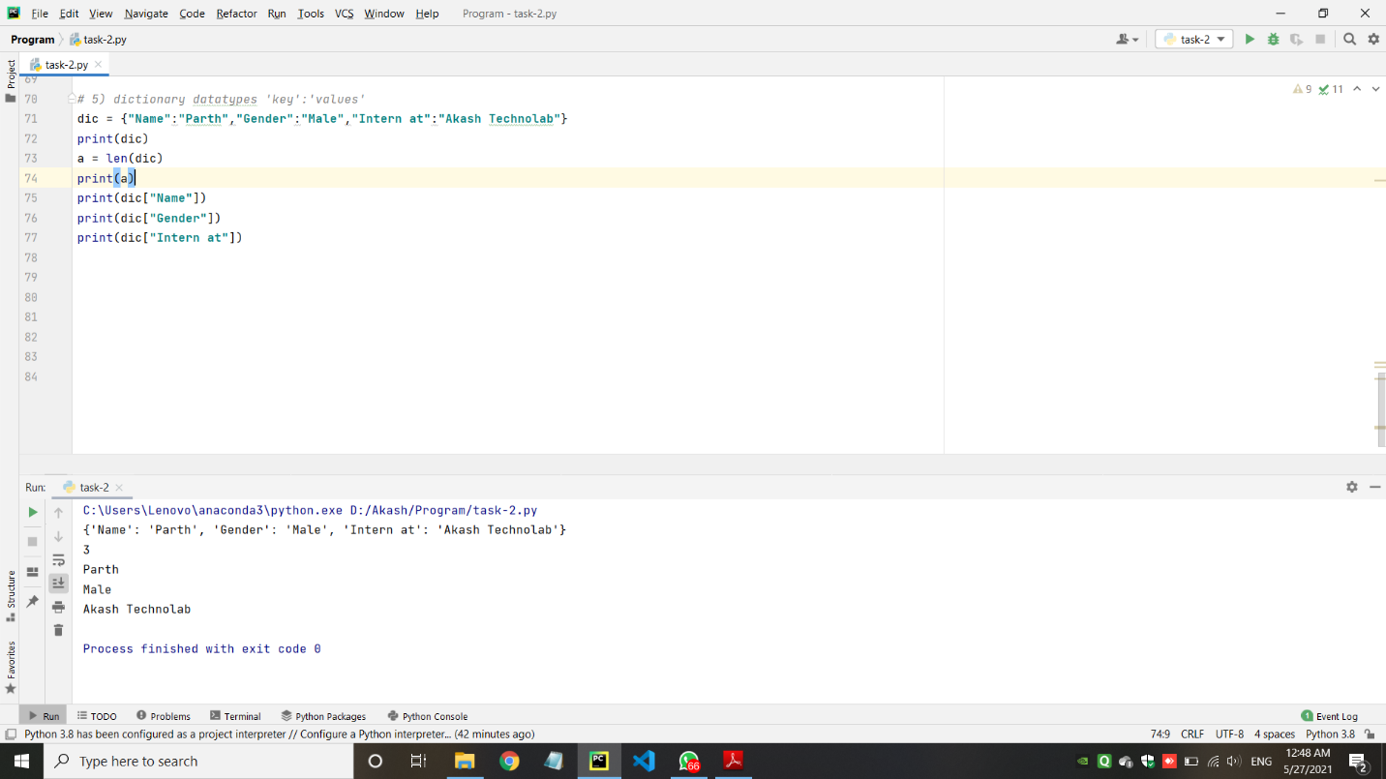

1. Task – 3: Python Conditional statement, Loops, Break, Continue, Range and Pass.

* Check whether number is even or odd.

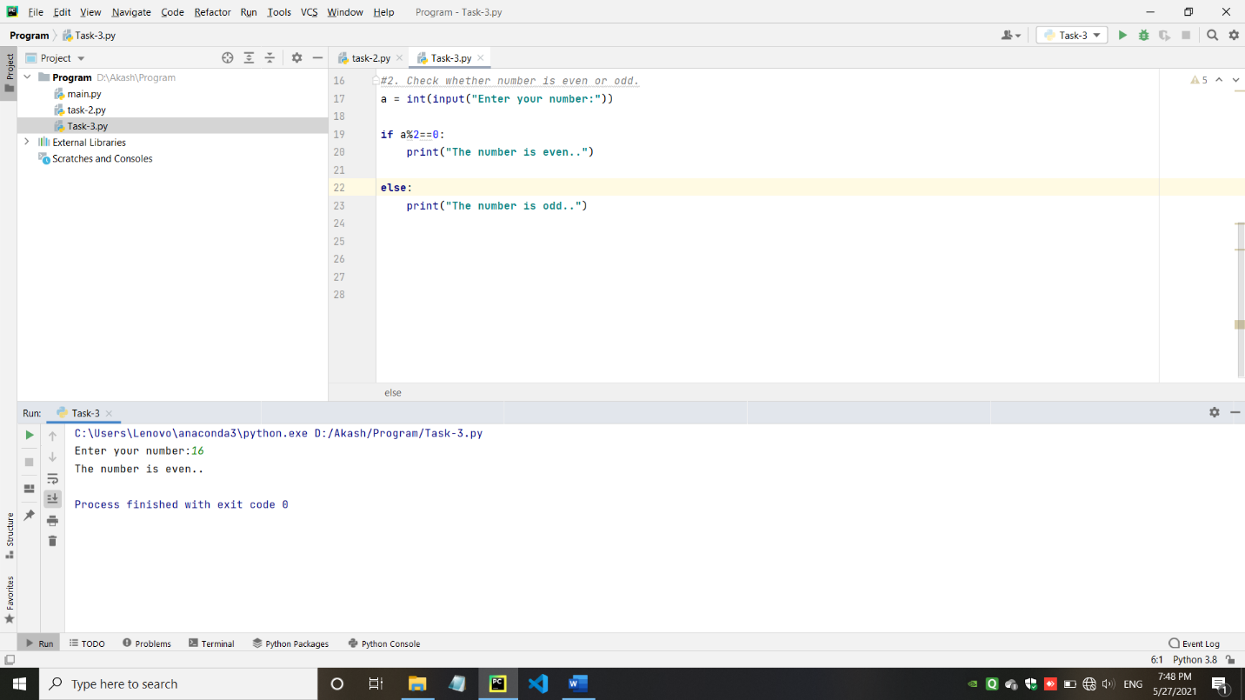

* Take a year and check whether it is leap year or not

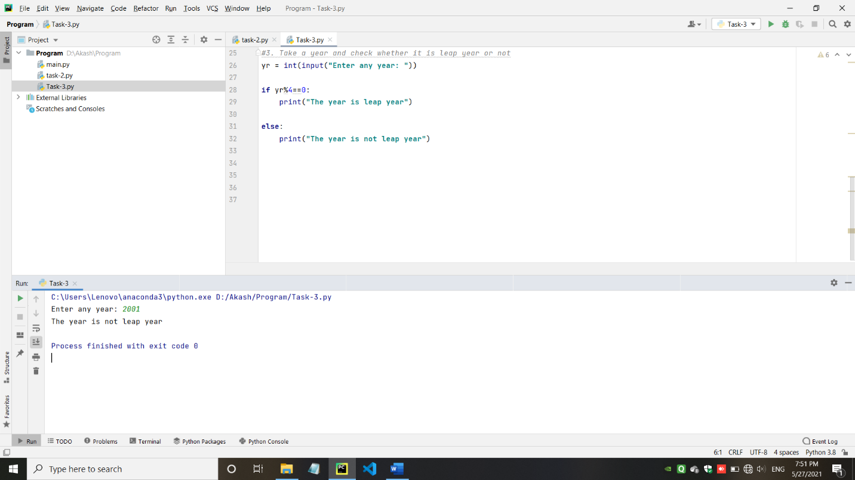

* Take a number and find factorial of that number.

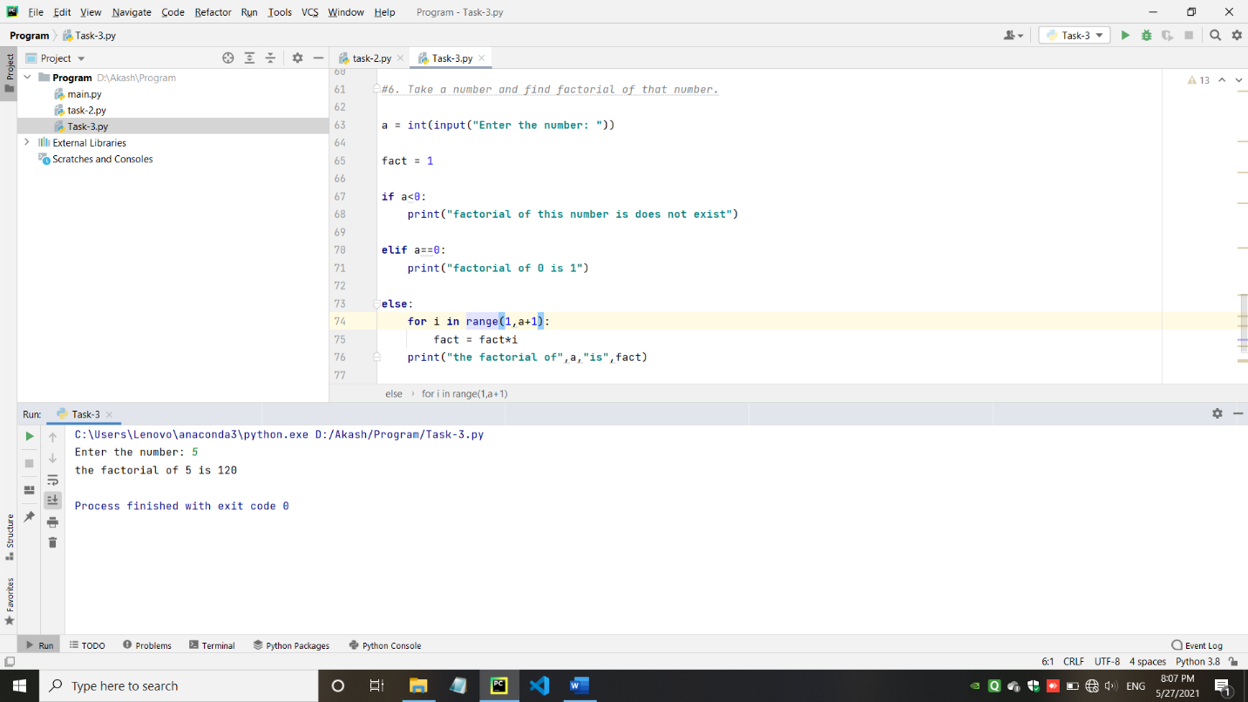

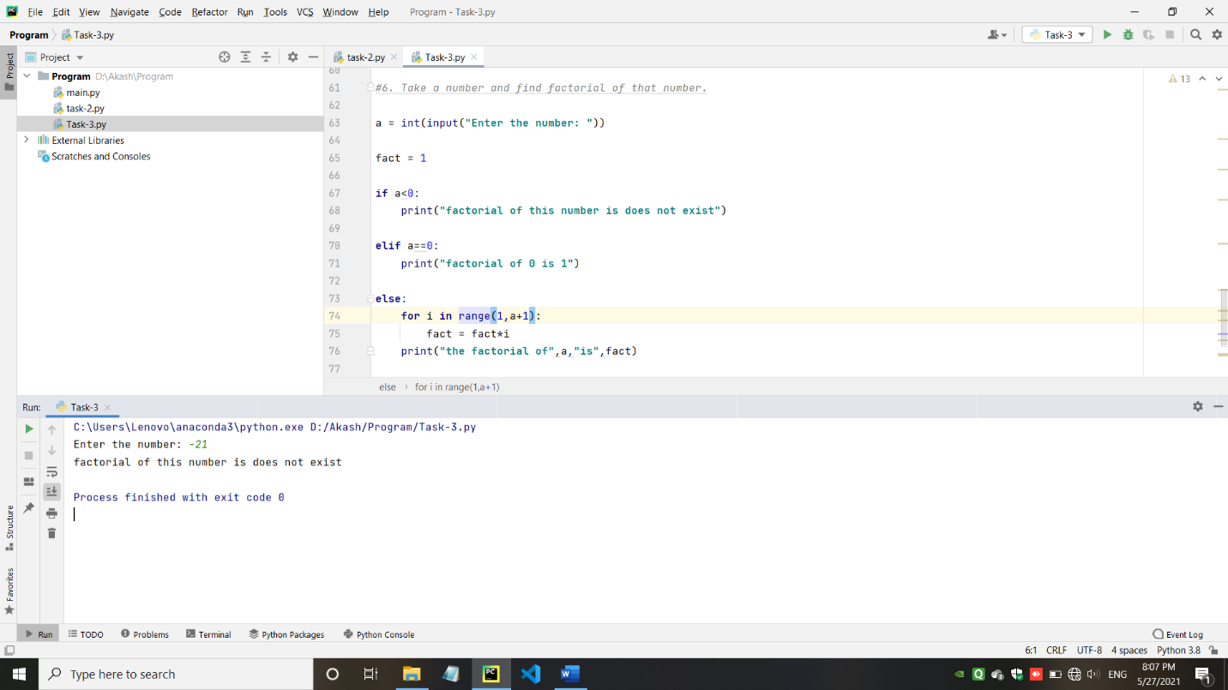

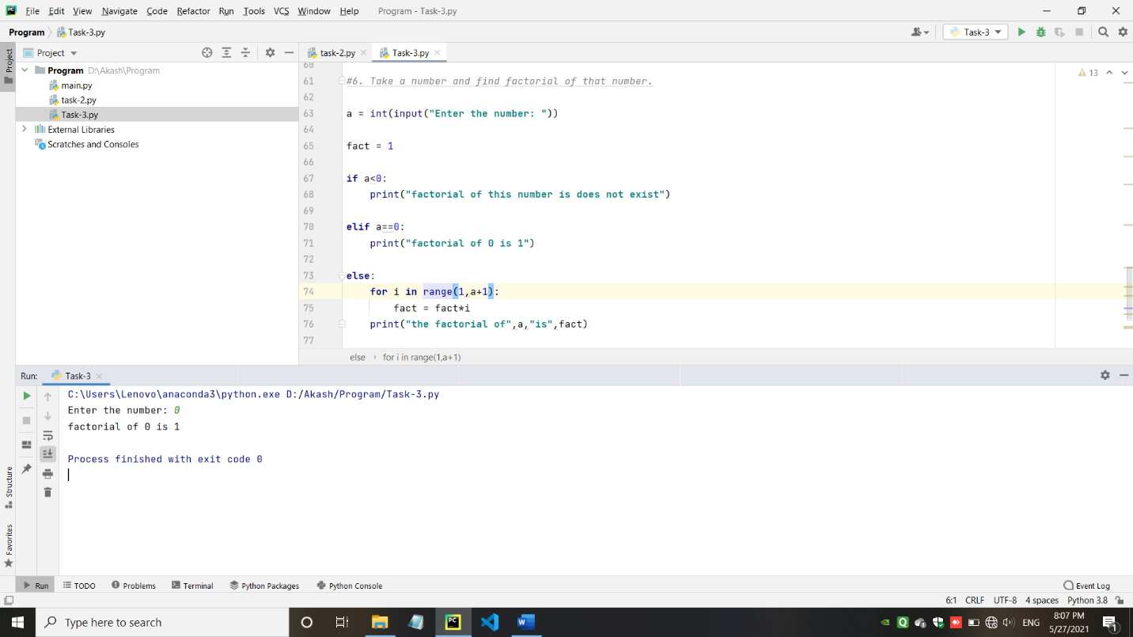

* Write a program to swap 2 numbers using third variable.

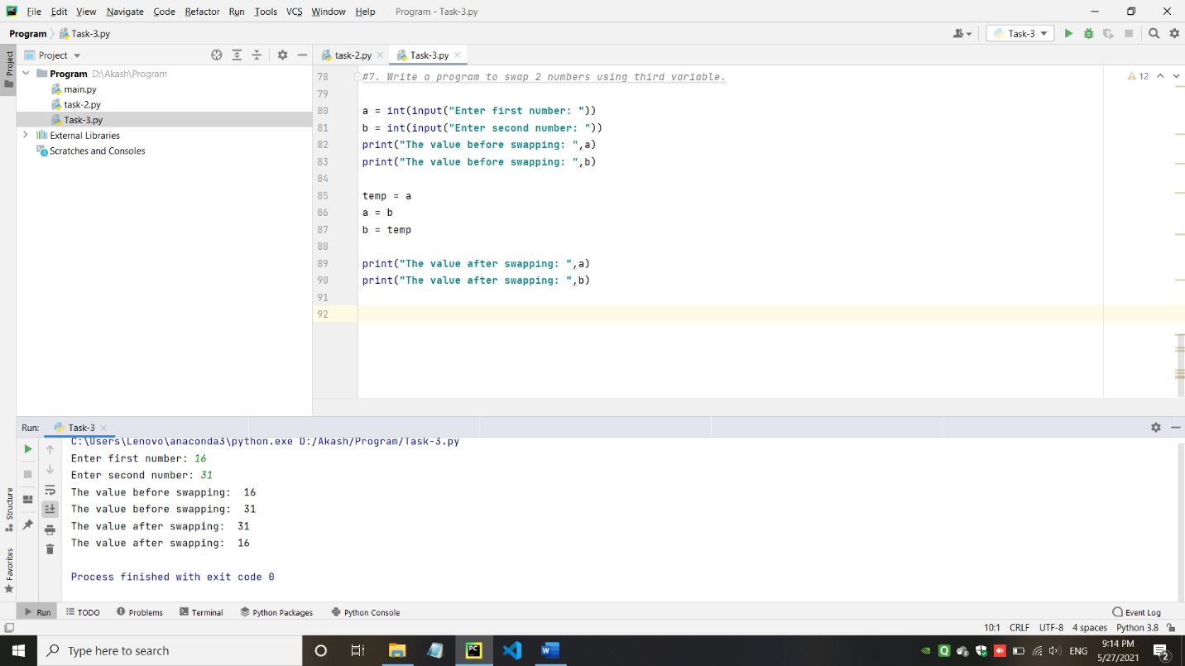

* Take a number check if a number is less than 100 or not. If it is less than 100 then check if it is odd or even.

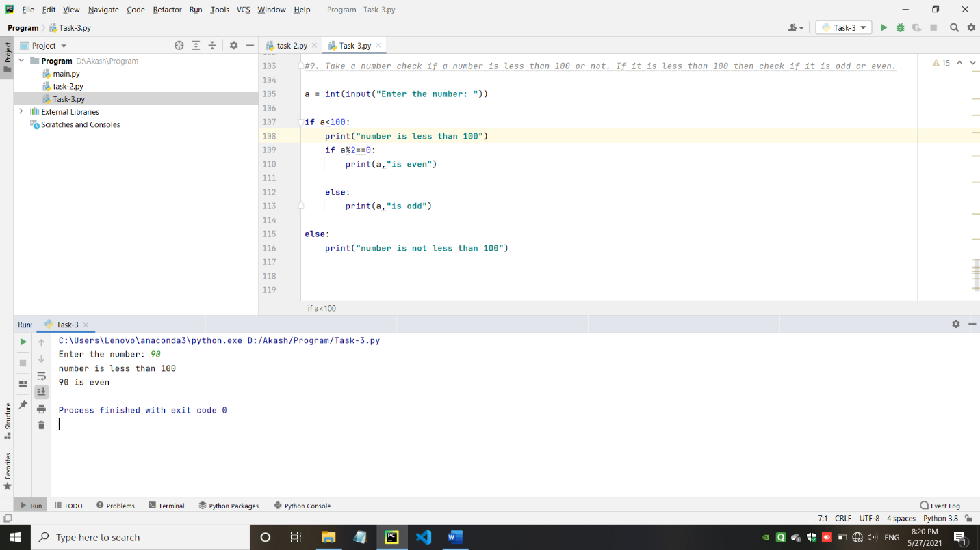

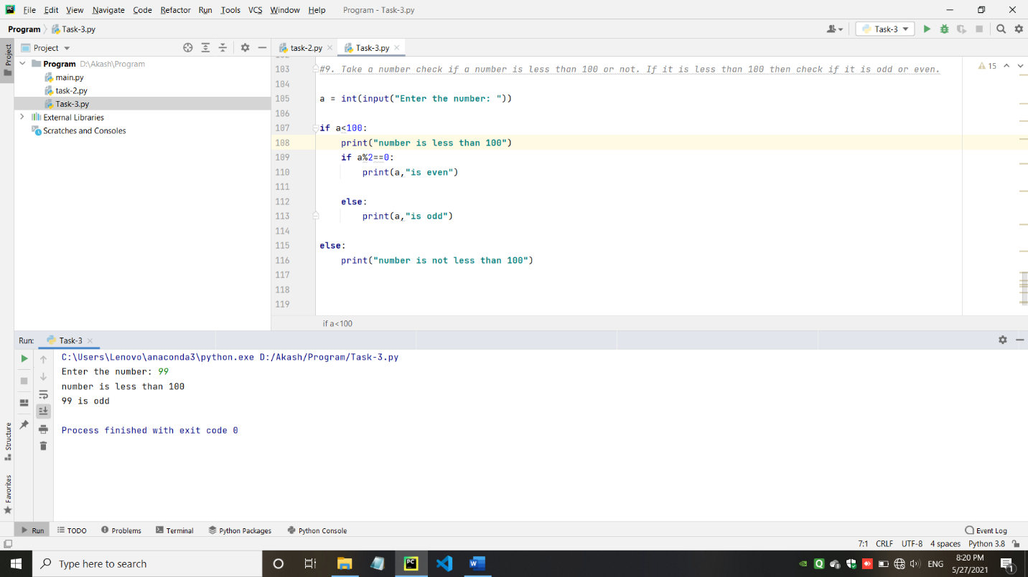

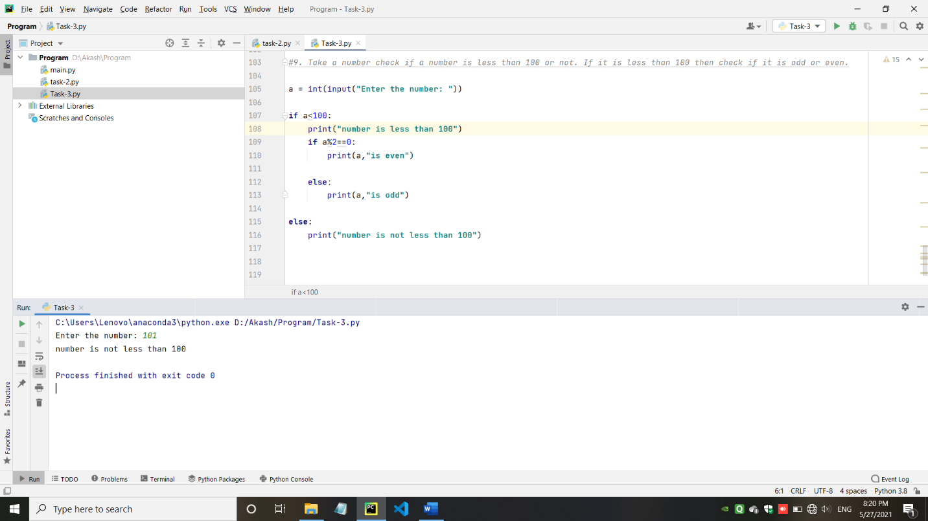

* Take a number to print the square of a number if it is less than 10.

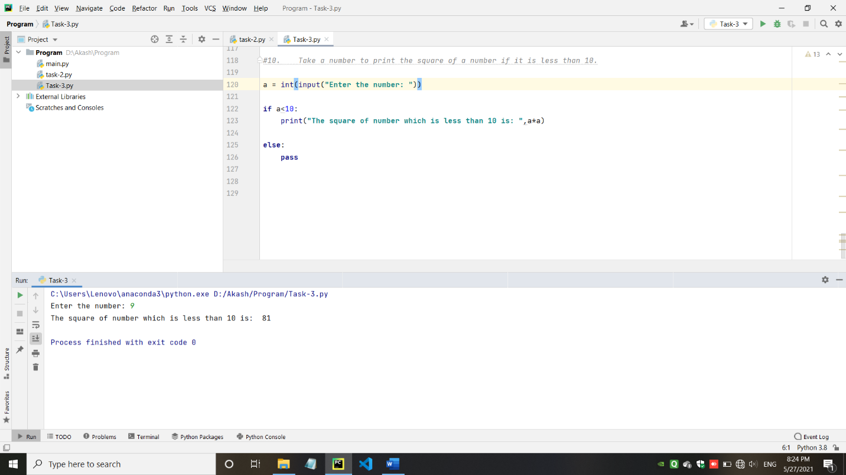

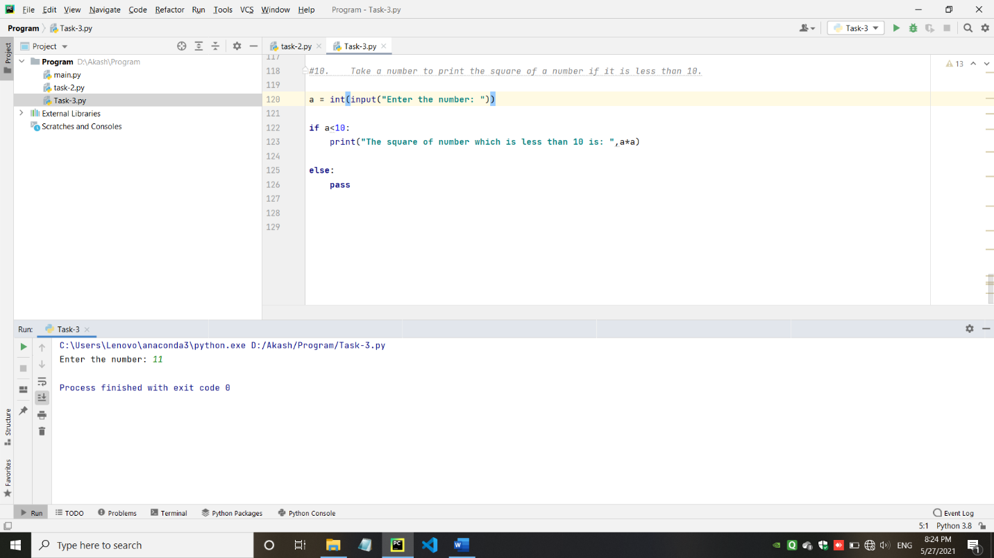

* Take 3 numbers and find greatest number using nested IF….ELSE statement.

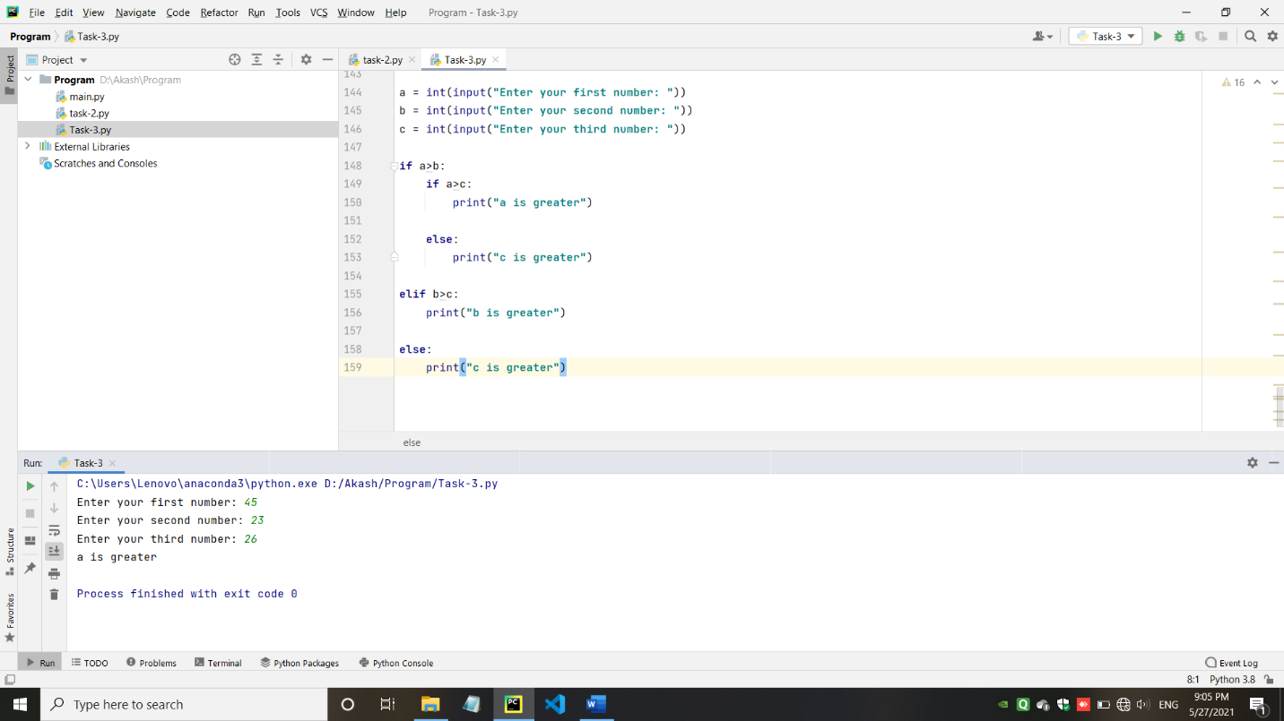

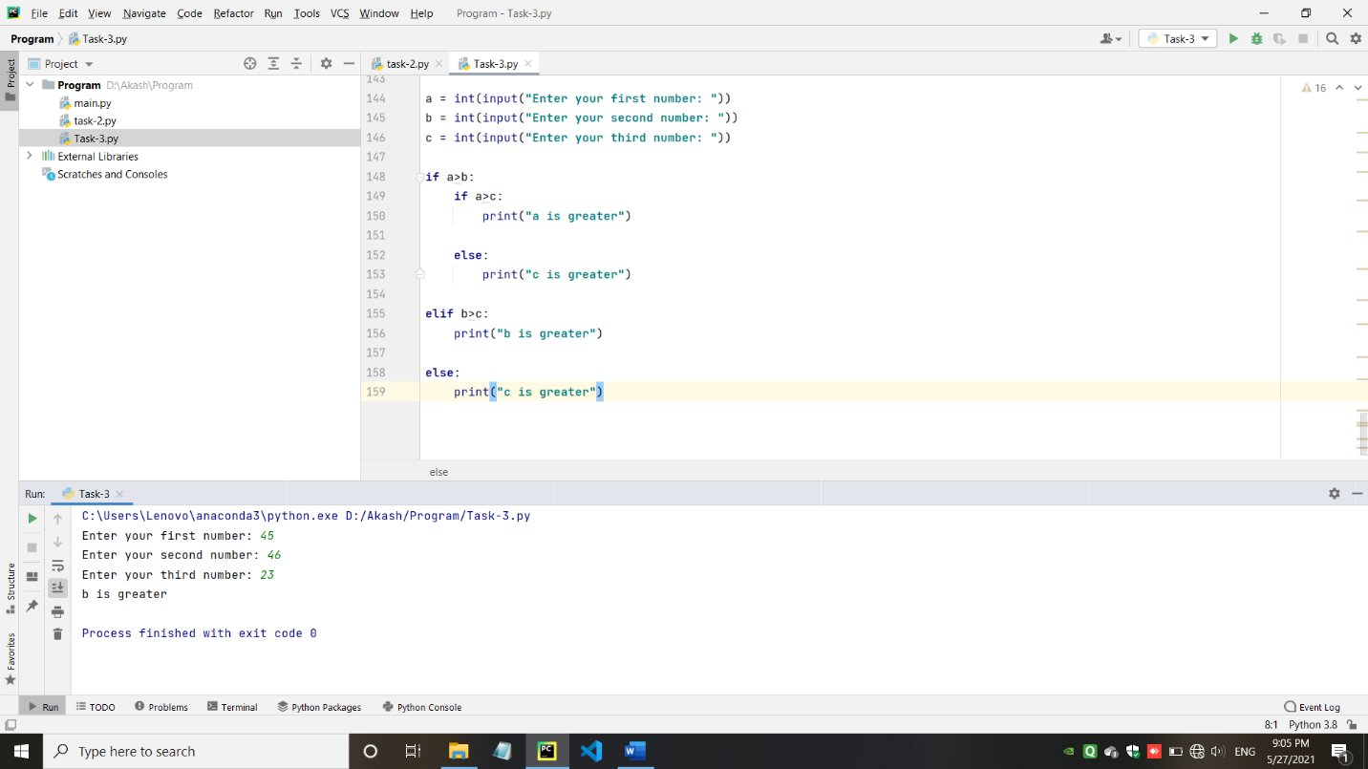

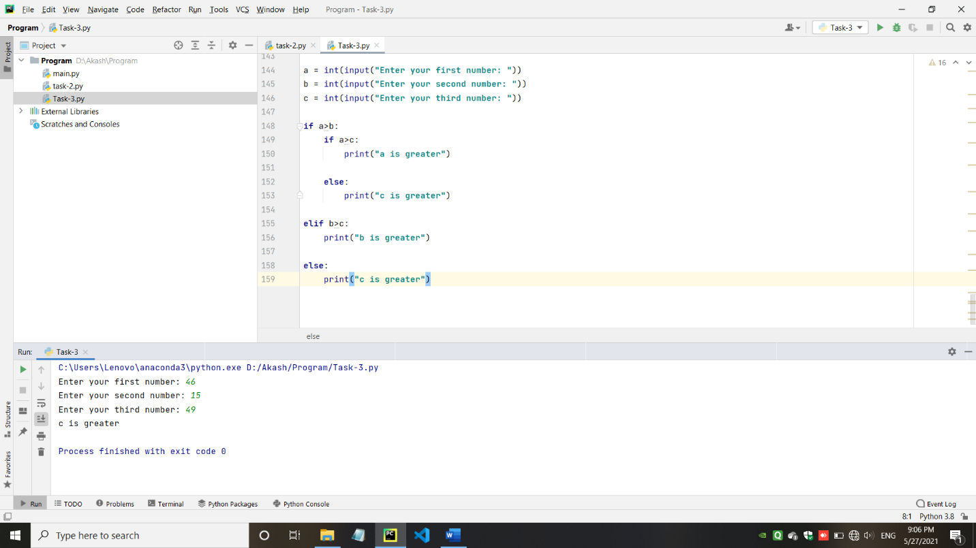

* Write a program to swap 2 numbers without taking third variable.

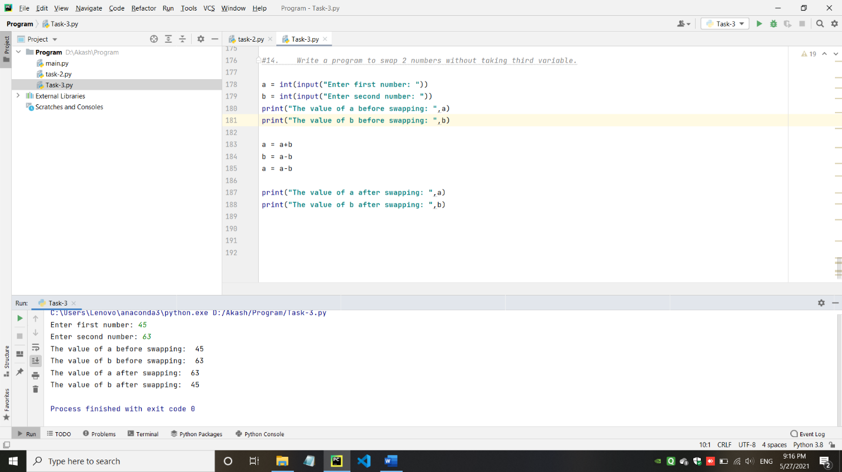

* Take starting number and ending number from the user and print following series.

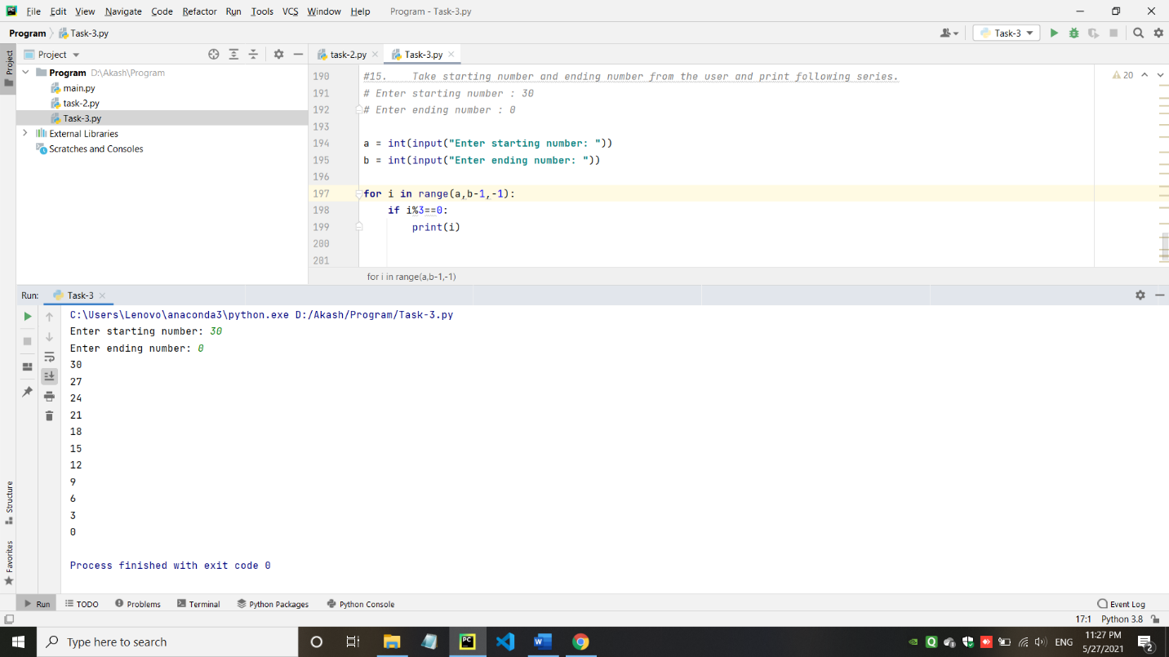

1. Python OOP’s Concepts.

* Create a class cal1 that will calculate sum of three numbers. Create setdata() method which has three parameters that contain numbers. Create display() method that will calculate sum and display sum.

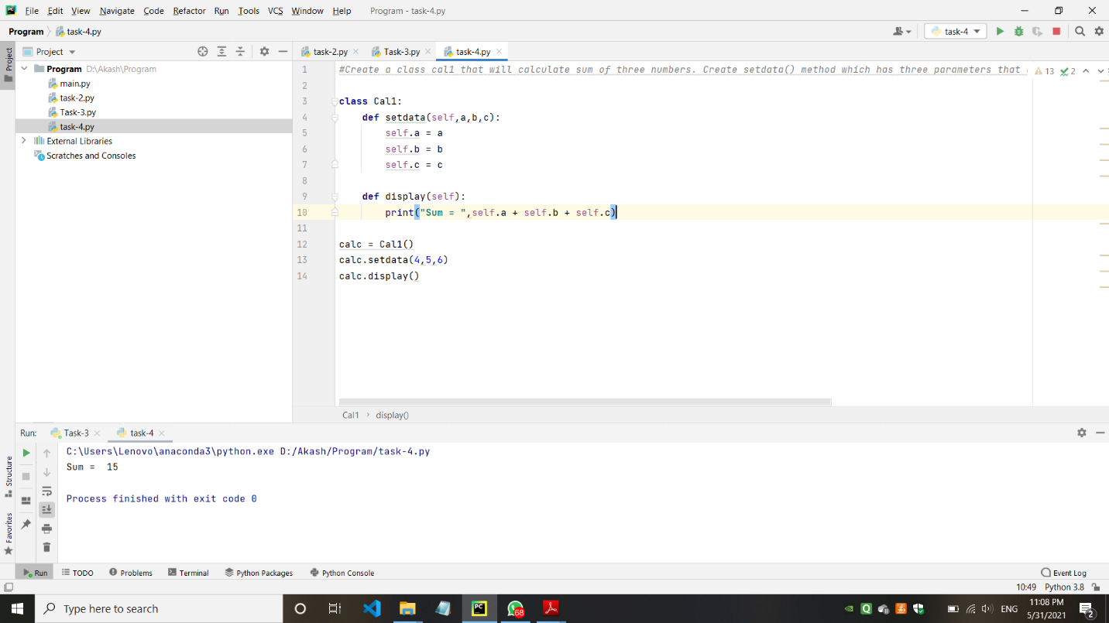

* Create a class cal3 that will calculate simple interest. Create constructor method which has three parameters .Create calInterest() method that will calculate Interest . Create display() method that will display Interest

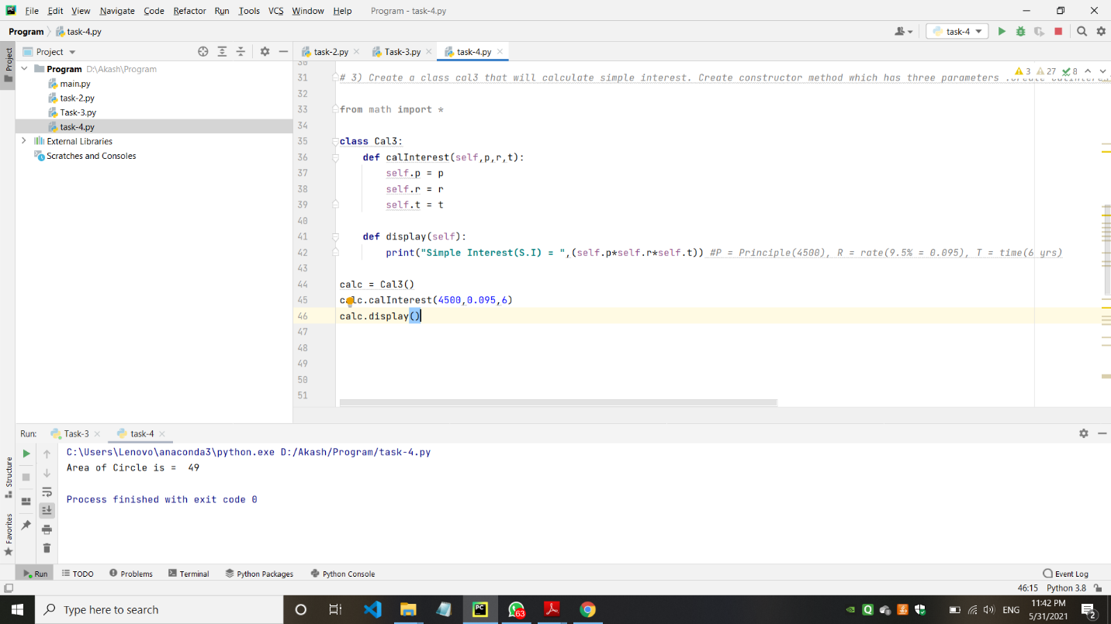

* Consider an employee class, which contains fields such as name and designation. And a subclass, which contains a field salary. Write a program for inheriting this relation.

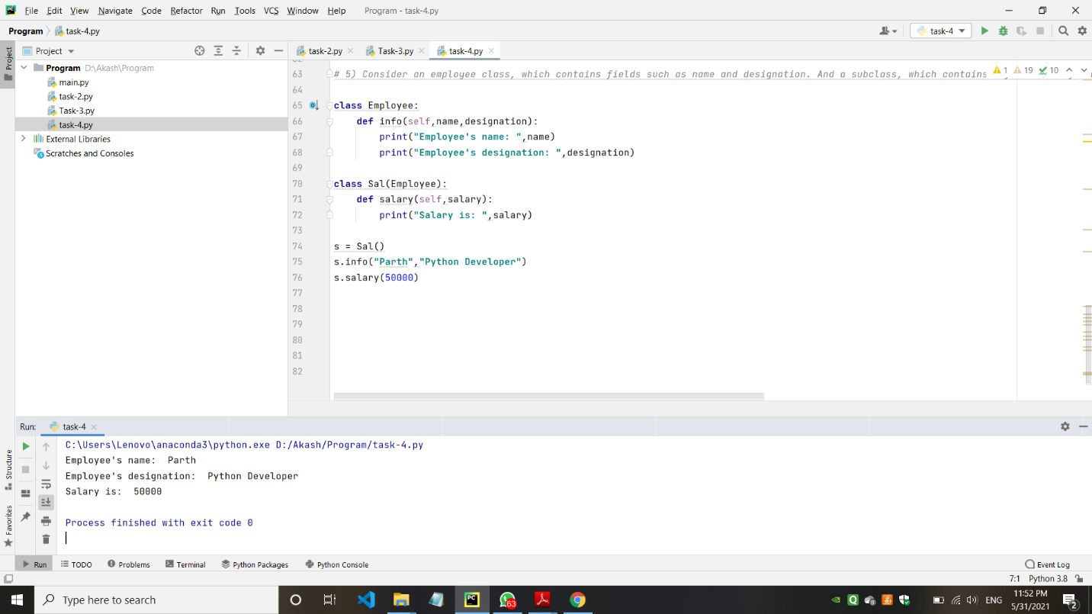

* Create a class cal5 that will calculate area of a rectangle. Create constructor method which has two parameters .Create calArea() method that will calculate area of a rectangle. Create display() method that will display area of a rectangle.

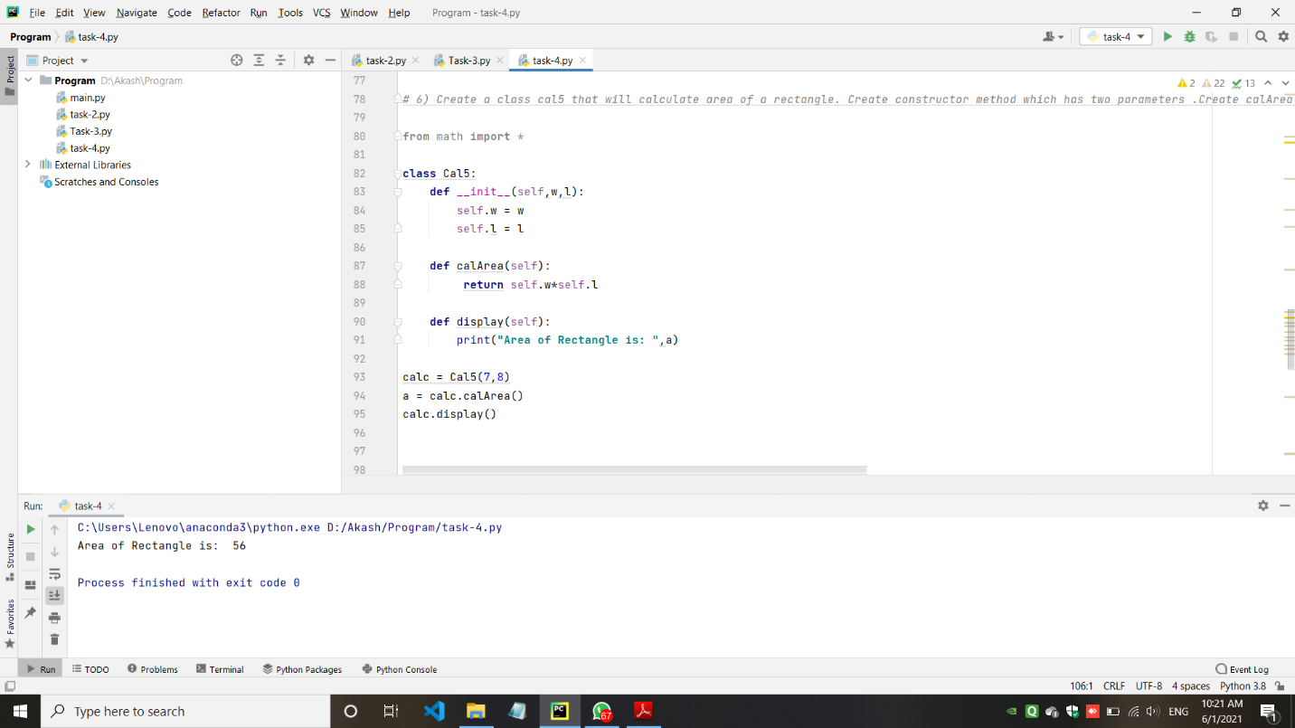

* Write a program with use of inheritance: Define a class publisher that stores the name of the title. Derive two classes book and tape, which inherit publisher. Book class contains member data called page no and tape class contain time for playing. Define functions in the appropriate classes to get and print the details.

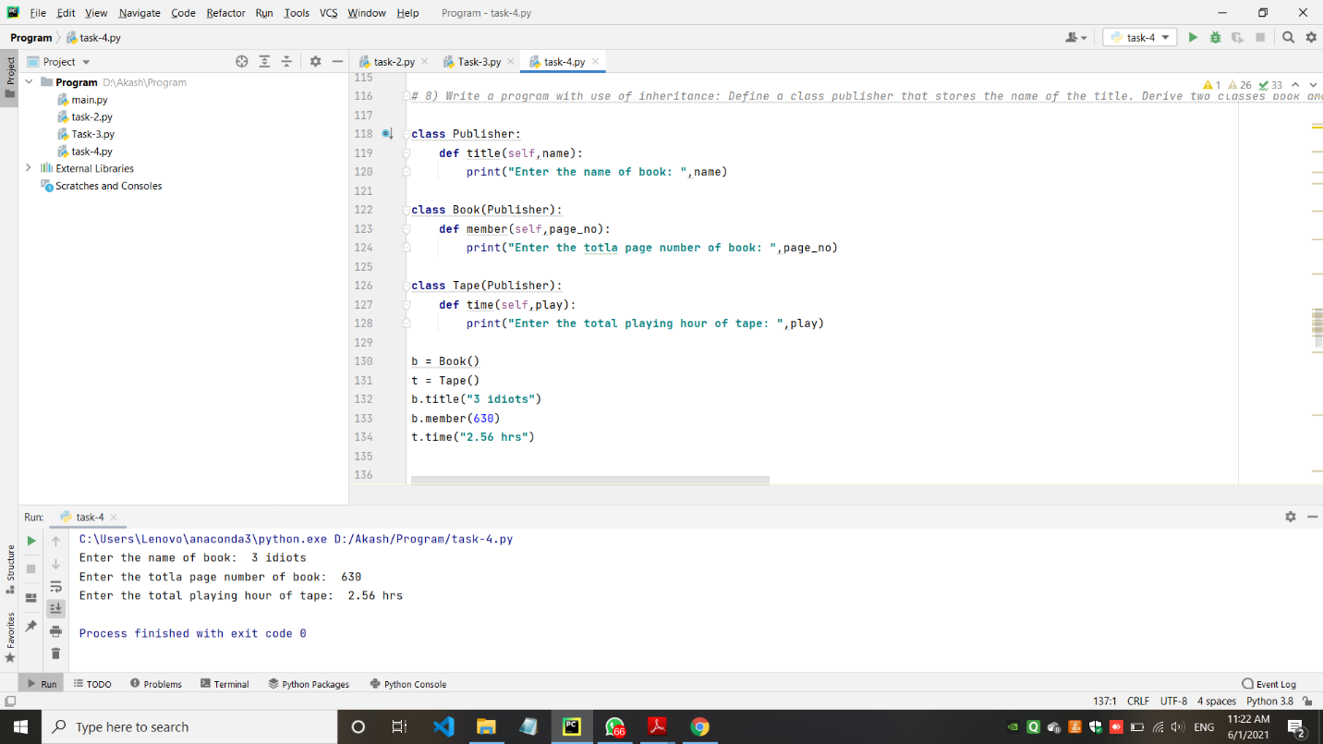

* Create an arith class. The class should have a parameterized constructor and methods to add, subtract and multiply two numbers and to return the answers.

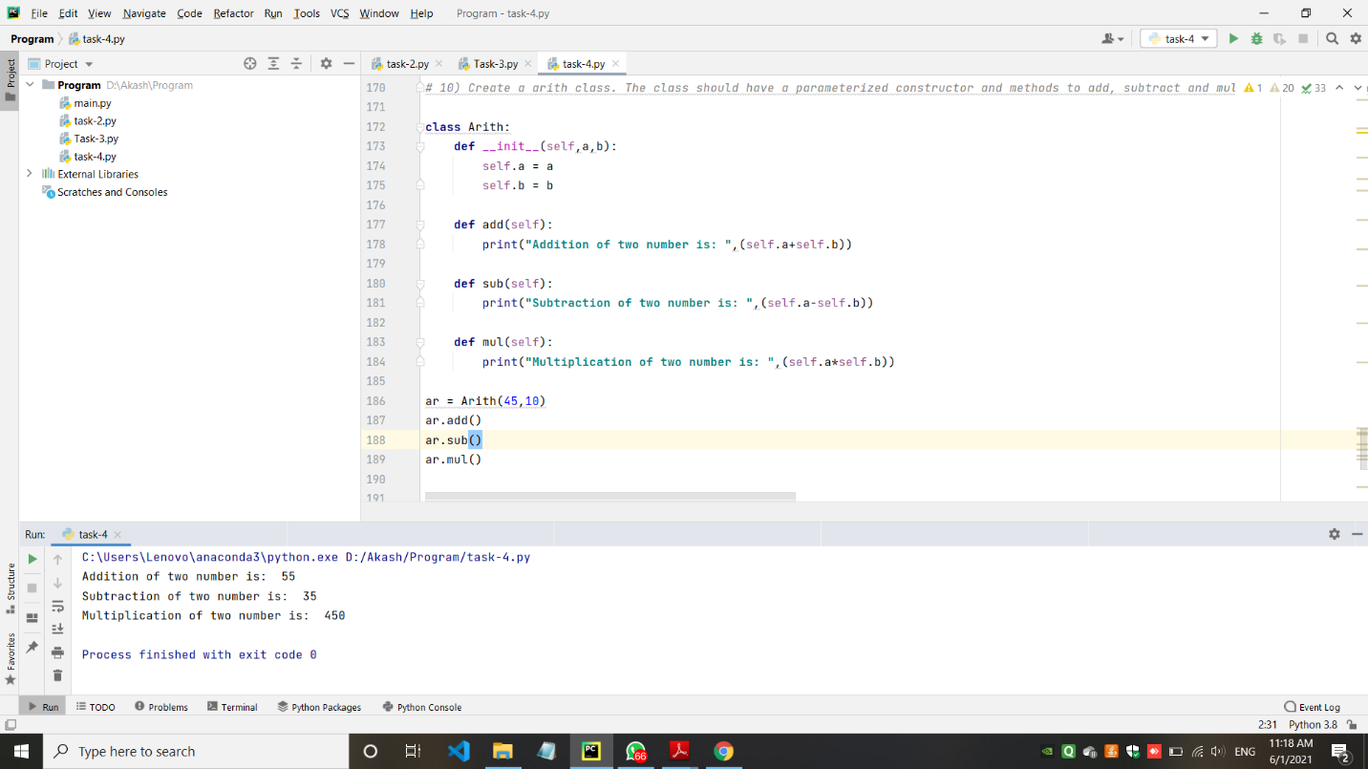

1. Task-5: Making simple pages using Django (Home, About, Contact).

* Views.py

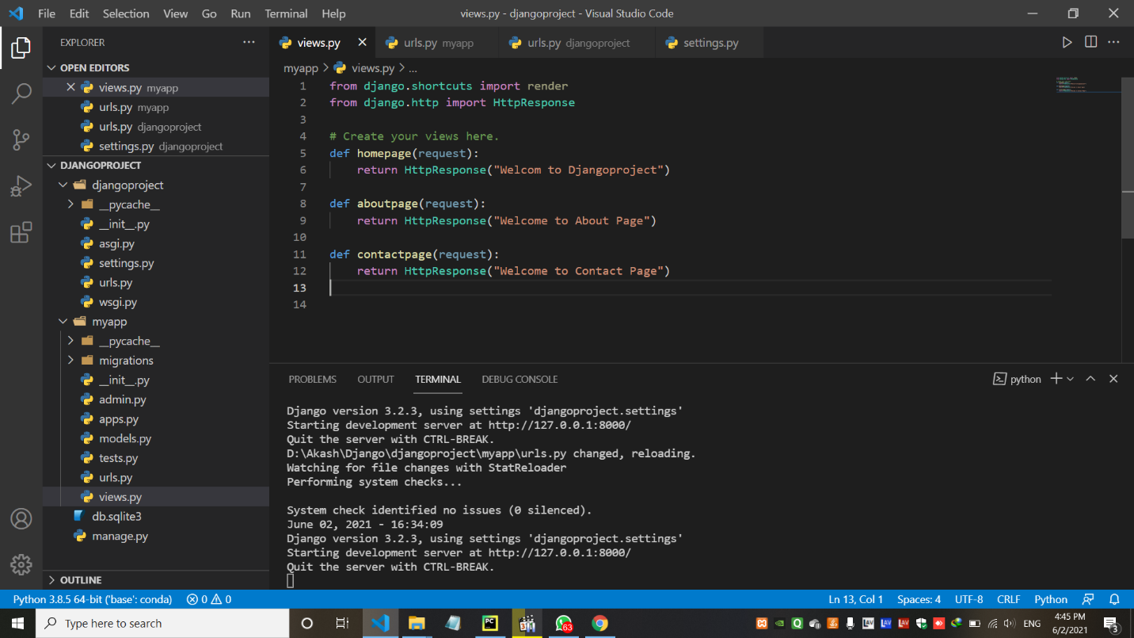

* urls.py (myapp)

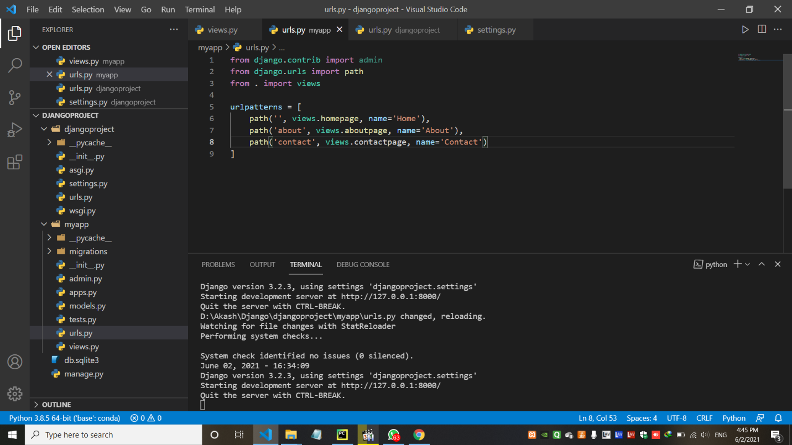

* urls.py (djangoproject)

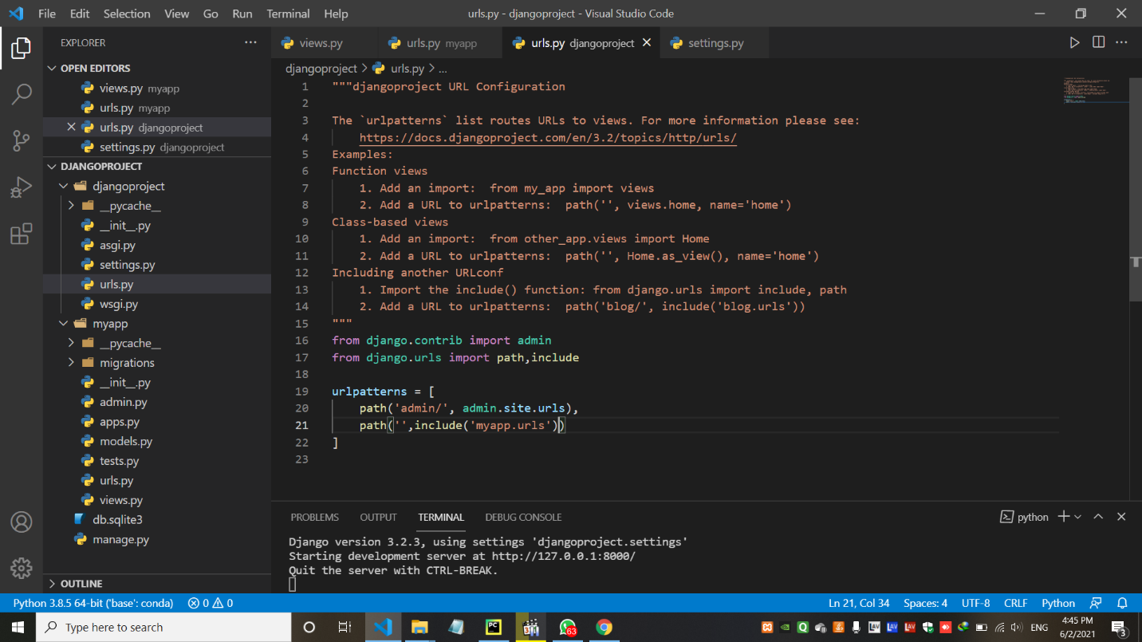

* settings.py

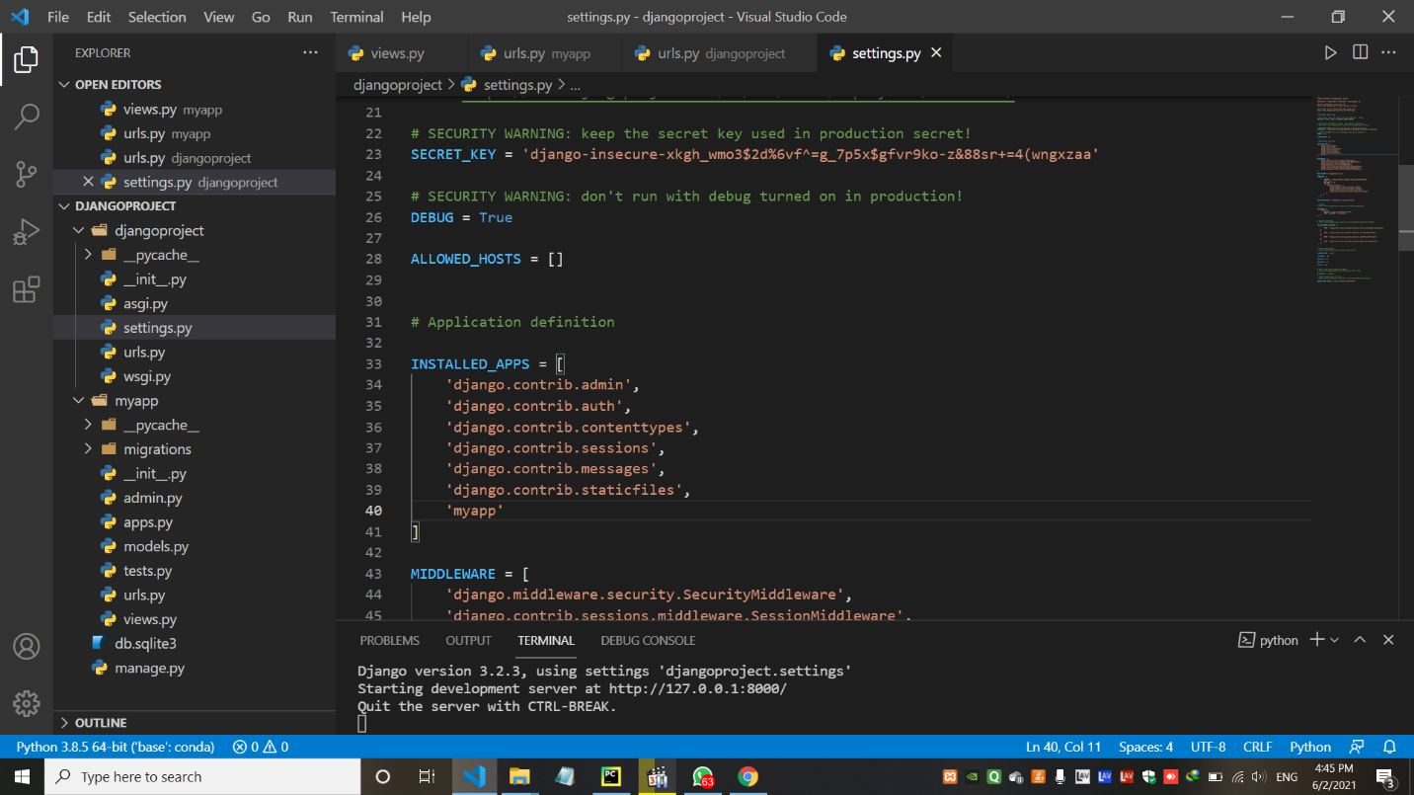

* Output – (Home Page with the text of Hello World)

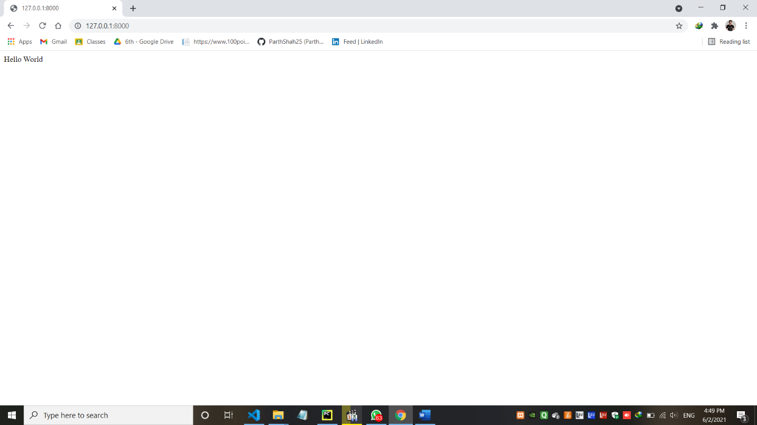

* Output – (About Page with the text of Welcome to About Page)

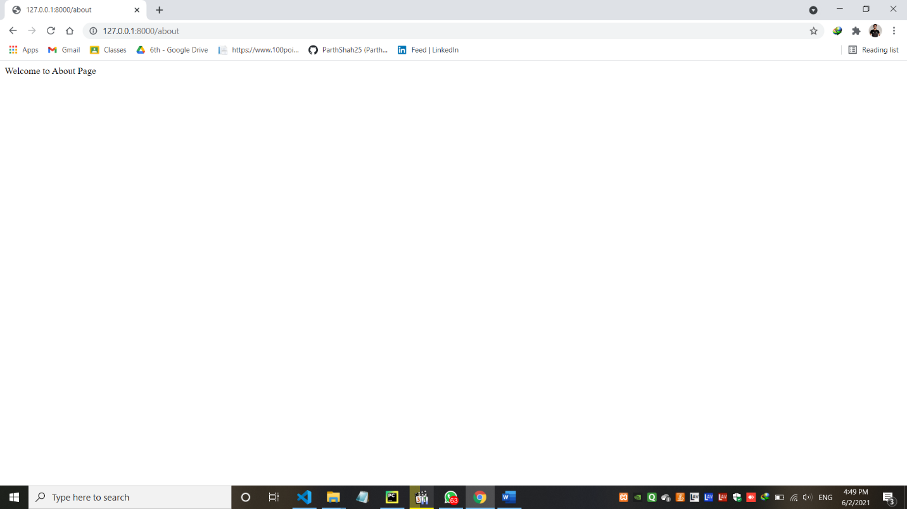

* Output – (Contact Page with the text of Welcome to Contact Page)

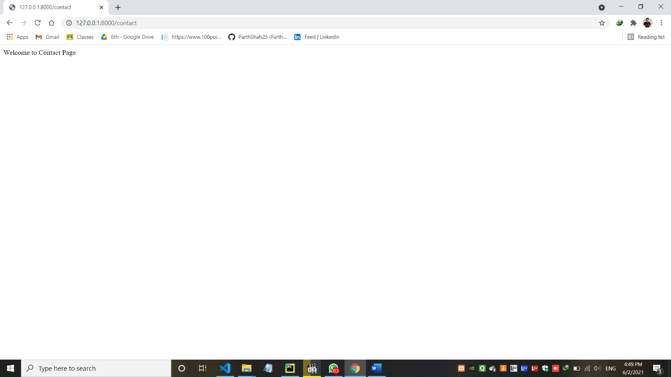

1. Task-6: Career Guidance website using Django.

* pgAdmin Database auth-user data with the use of register page

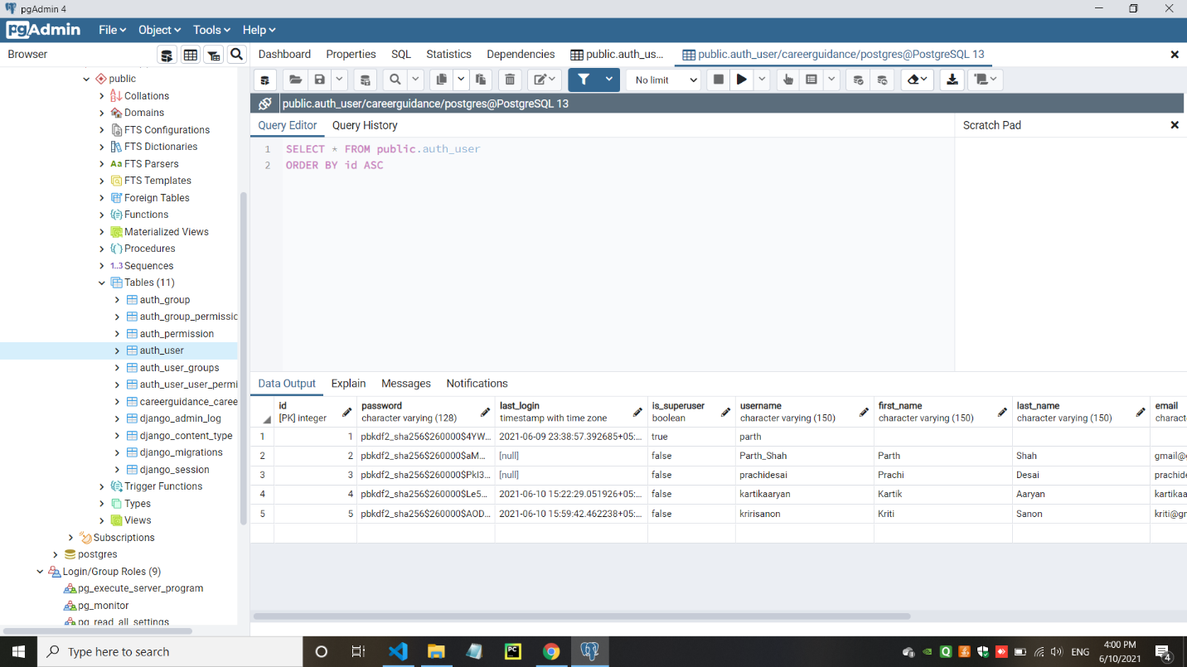

* Django/Admin panel data entry by the register page

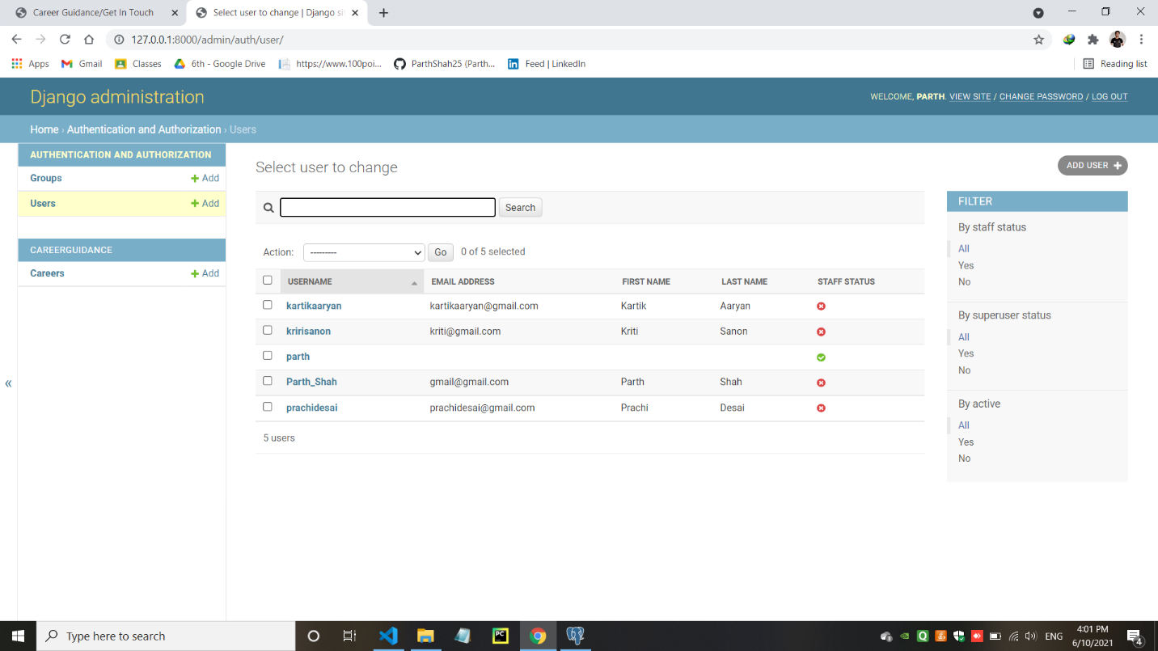

* CRUD operations using models.py page in the Django/Admin panel (Data Entry)

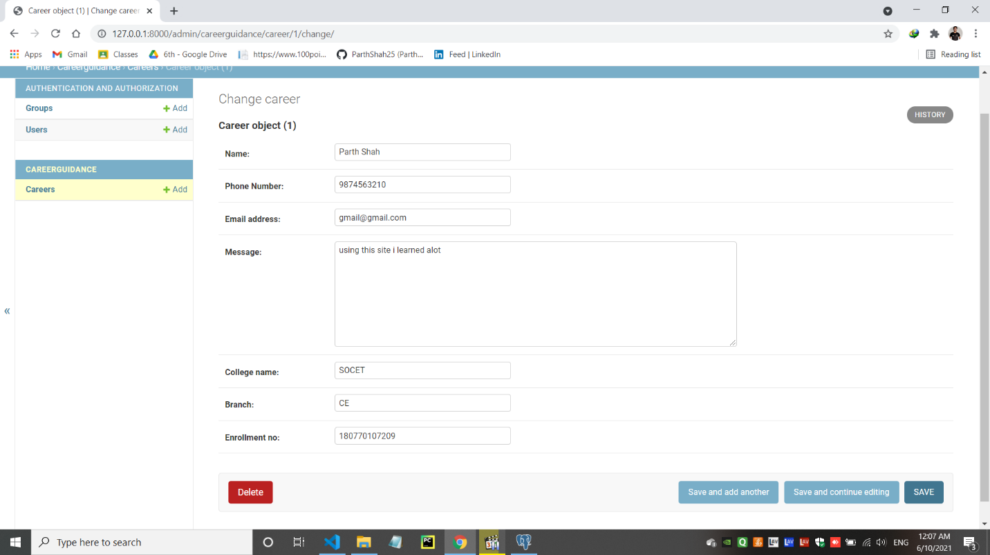

* CRUD operation’s Data store in the Django/Admin Panel.

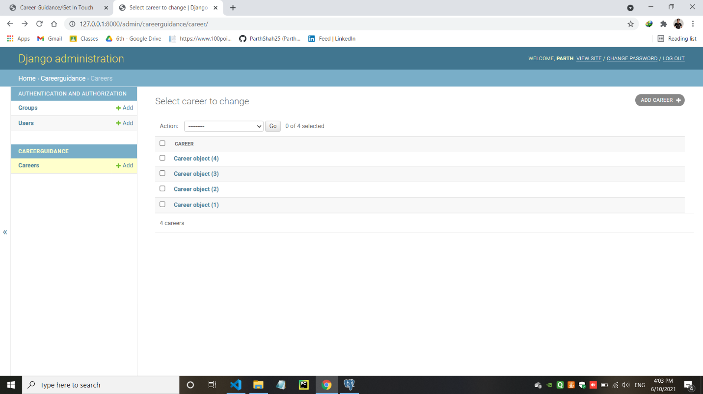

* When Data store in the Django/Admin panel they will also added in the pgAdmin Database

